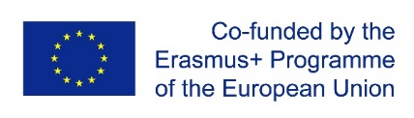

**Call for experts: 5th Series of LEAD workshops**

**1-5 May 2018**

**Middle East Technical University (METU), Ankara, Turkey**

**The LEAD project** is an Erasmus+ KA2 Capacity Building in the field of Higher Education (CBHE) The project is supported by the European Commission.

Website: http://lead-project.org/

**1. Please mark one of more topics you would be willing to present on during the training sessions of the Workshop:**

|  |  |
| --- | --- |
|  | New concepts of leadership: distributive & collective leadership |
|  | Negotiation and conflict management |
|  | Innovation & innovative processes in HE creative mentality; policies for innovation |
|  | Social innovation and educational innovation |

**2. Please describe shortly your experience and your University's practices in regard to the selected topics:**

|  |
| --- |
|  |

**3. Please provide us with your short biography (200-300 words):**

|  |
| --- |
|  |

***Please send the form to Marta Brelih-Wasowska: marta.wasowska@unica-network.eu by Monday, 29 January 2018.***