HOTEL METROPOLE

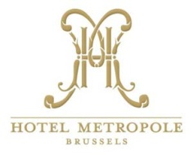

The participants interested in booking a room in Hotel Metropole are kindly asked to contact directly:

To : Reservations Hotel Métropole, Brussels
Fax : +32-2-218 02 40
Tel : +32-2-214 24 25 or +32-2-214 24 26
Email : resa@metropolehotel.be

Please use the following booking Code: "ULB"
Please book the room at your earliest convenience. The reservations will be made on a room availability basis.

Prices:
- Single Superior, single occupancy at 169.00 € including breakfast
- Single Privilege, single occupancy at 199.00 € including breakfast
30.00 € for upgrade to double room

Both room rates include all taxes & service charges

